

How to use Powerbi load report and deploy report

Author: Catherine

Contents

Prerequisites 2

Load JSON in Power BI Desktop 2

Create workspace for displaying and sharing reports 6

Publish reports 6

Share reports 7

Manage permissions of accessing reports 11

Export report PDF from Power BI 12

# Prerequisites

1. Download **Power BI Desktop**. If you have it make sure it’s the latest version.

Power BI Desktop is hosted in **Microsoft Store**, launch Store, input “Power BI” in search box, find it in the search result. Install it in your machine.

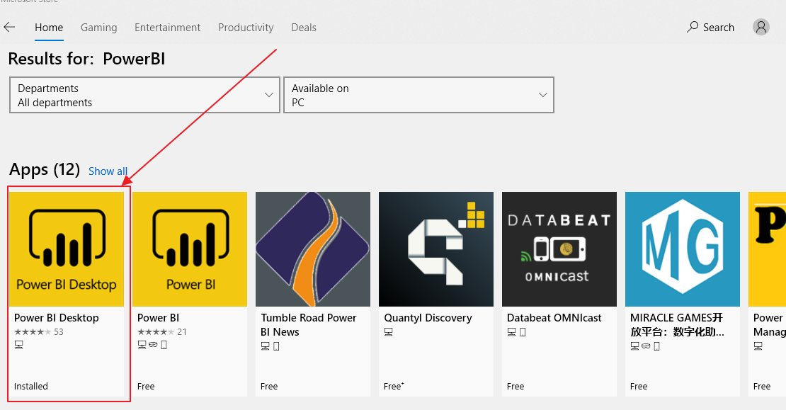

1. Get the JSON file of the report you’ll use. Login to OneDrive, find the folder of the project, go to “**Reports**” folder. The “**District**” folder contains all surveys’ result of the whole district, and other folders is for each school.

Download the json file you need.

# Load JSON in Power BI Desktop

1. Launch Power BI Desktop, and sign in your organizational account.

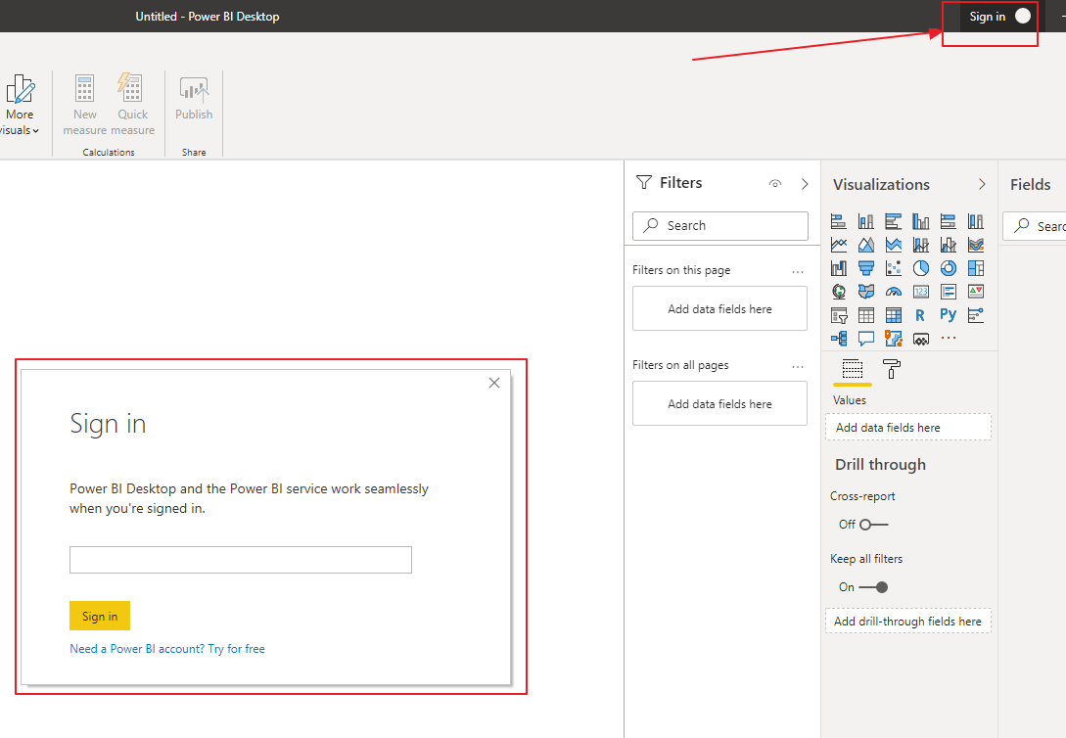

1. Download and Open **SchoolTransformationSurvey.pbix** in Power BI Desktop. This pbix hosted in <https://canviz.visualstudio.com/_git/School%20Transformation%20Survey?path=%2FReports%2FSchoolTransformationSurvey.pbix> . (This url will be updated if deployed to client repo)
2. You’ll see pages and reports, its source is sample data, you need to change the data source to the json file you got in Prerequisites #2 .

From the menu list in Power BI Desktop, click the chevron beside **Transform data**, you’ll see a pop up, click **Data source settings**.

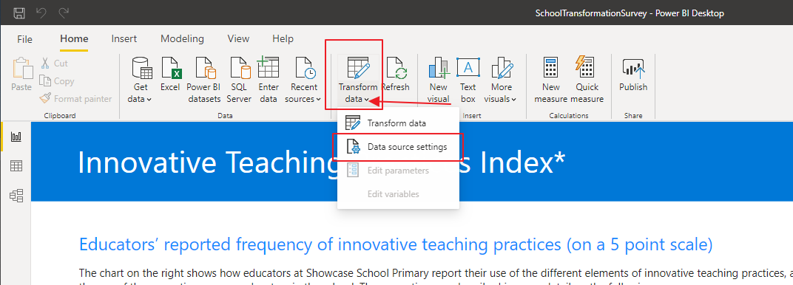

1. In Data source settings, click “**Change source**…”

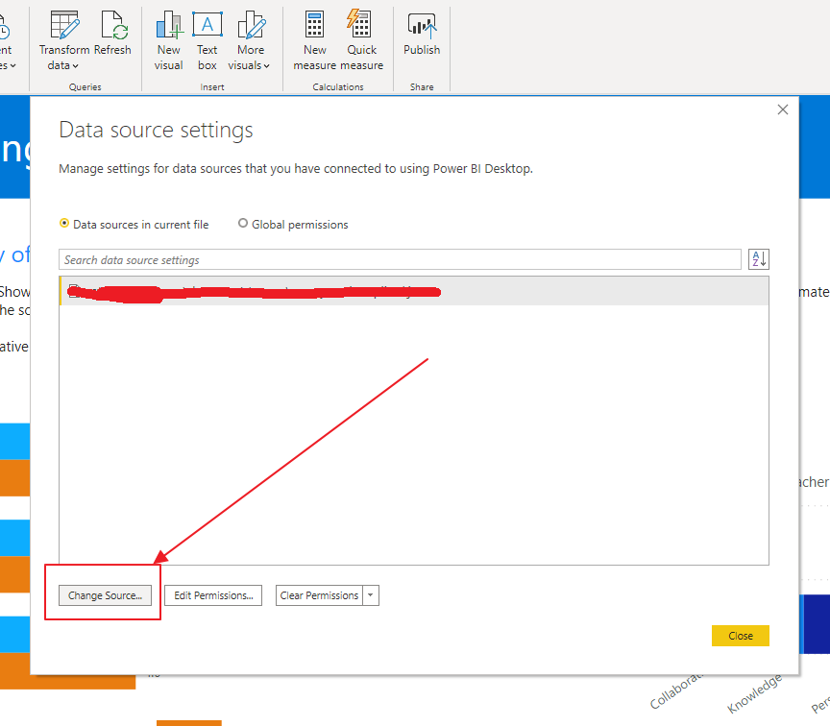

1. In JSON pop up, click Browse to select JSON file, keep Open file as Json, click Ok, you’ll see the file listed in Data source settings, then click Close.

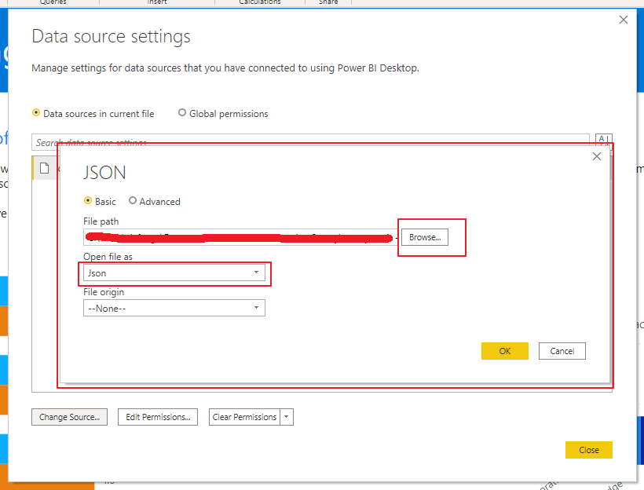

You may encounter this message after closing data source settings, just click **Apply changes**, and wait for a few minutes let applying done. You’ll see updated report.

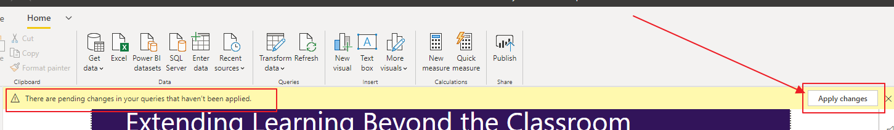

# Create workspace for displaying and sharing reports

1. After reports showed correctly, you can start to publish and share reports to others. Before publish reports, you need a workspace in Power BI site, login <https://app.powerbi.com/> using your organizational account.
2. From menus in the left click Workspaces, and click Create a workspace in the right pop up. Input a name for workspace and save it. Remember the name for next steps.

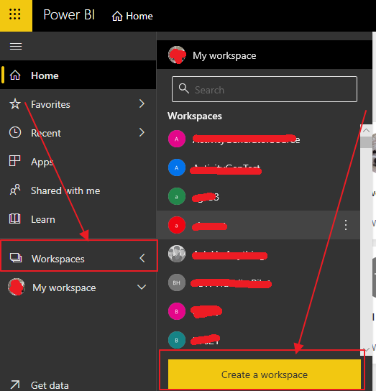

# Publish reports

1. Go back to Power BI Desktop, Click **Publish** in top menus, select the workspace you created in previous step, then click Select.

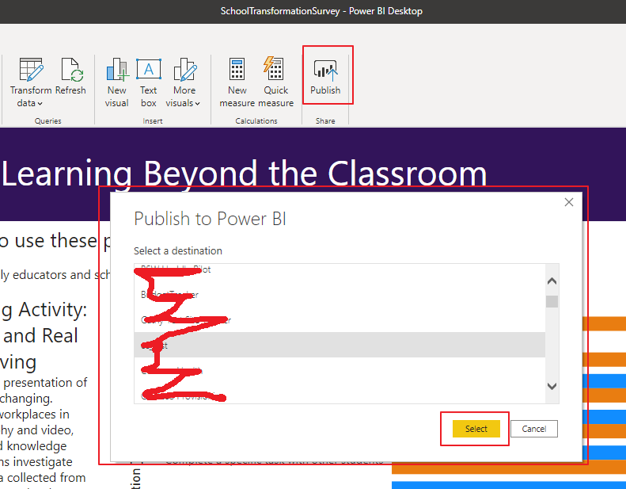

Wait for a few minutes until publishing done.

# Share reports

1. Go to <https://app.powerbi.com/> , open the workspace you created. Click Reports in your workspace.

You’ll find the report you published from Power BI Desktop.

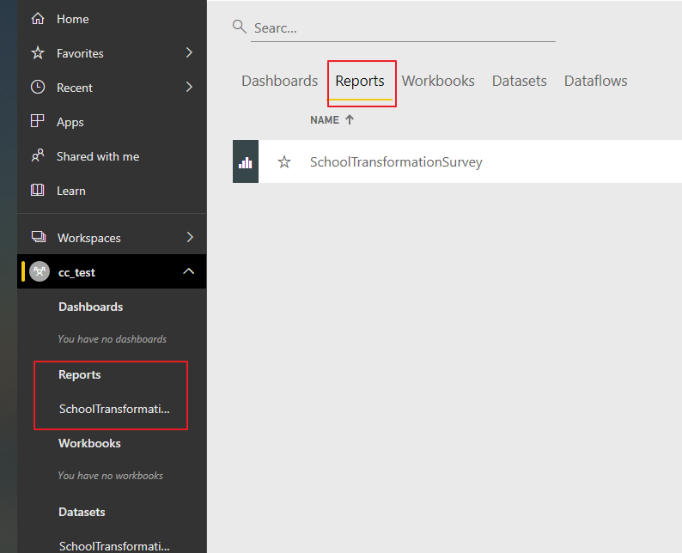

1. Click share icon under ACTIONS of the report to share report.

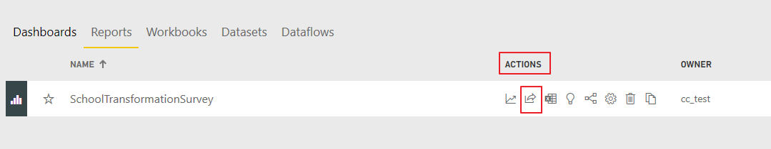

1. Grant access with emails, input user’s email under your organizational tenant in box#1. If you don’t want recipients share your reports or build new content, please remember **uncheck** items in #2.

Then click Share. User will receive a email with report link #3.

Note: If the user you share to is a guest in your tenant, the user cannot re-share the report even you grant re-share to him. As a guest user, only Read-Only access.

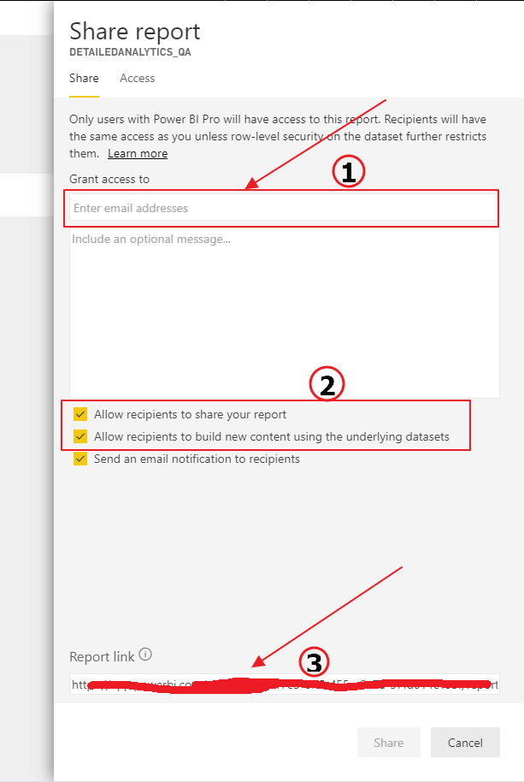

# Manage permissions of accessing reports

1. After granting access to users, you may want to change their permission. Open the pop up Share report, Click Access, you’ll see everyone’s access, click the ellipses behind ACCESS, choose the permission you want to set.

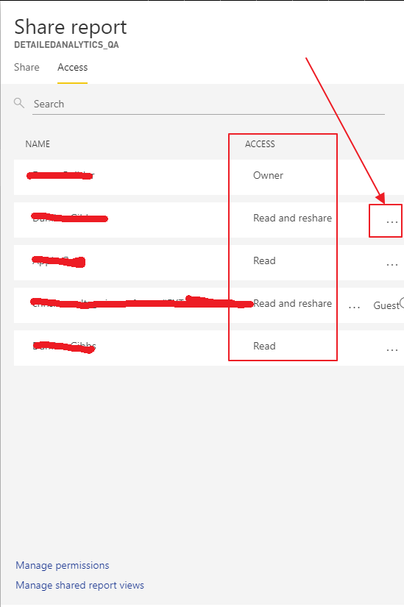

# Export report PDF from Power BI

After you load survey data to Power BI Desktop successfully, you can export all reports to a PDF.

1. Open **SchoolTransformationSurvey.pbix** in Power BI Desktop, Click “**File**” from top menu list, click “**Export**” from pop up menu, then click “**Export to PDF**”.

Wait for a few minutes, this procedure will generate **all reports** to a PDF file.

The PDF file will be opened in Browser.

